

Experiences Worksheet

The Experiences feature is a great way to highlight outside-of-the-classroom opportunities in Presence. It is extremely customizable and can encompass a wide variety of programs. Everything from Awards, Internships to Orientations can be built as an Experience.

1. [What are Experiences?](https://presence-support.moderncampus.com/hc/en-us/articles/17764712400269-What-are-Experiences) – Article
2. [Intro to Experiences](https://presence-support.moderncampus.com/hc/en-us/articles/22851091438477-Intro-to-Experiences) – Video

|  |  |
| --- | --- |
| **Your Institution:** |  |
| **Your branding guidelines:**  ***Please provide the Hex color codes or a screenshot of your branding guide colors to use when making your tiles and headers.*** |  |

**Setting up your Experiences is a 3-step process.**

1. Define your Experience Types and Experiences.
2. Plan the layout and content for your Experience Type landing pages.
3. Plan the layout and content for your Experience landing pages.

## Step 1: Plan Your Experience Types and Experiences

*Make as many copies of the experience type planning table as you need!*

|  |  |  |
| --- | --- | --- |
| Experience Type:  (This is your “bucket” category) | | |
| What is your goal for this Experience Type? Why are students working toward earning it? | | |
|  | | |
| Experience | What requirements will students  meet to earn this Experience?  *(What will they do/complete/learn/attend/etc.?)* | What will this connect to in Presence? Do you need to build a new event/tag/form/etc.? |
|  |  |  |
|  |  |  |
|  |  |  |
|  |  |  |
|  |  |  |
|  |  |  |

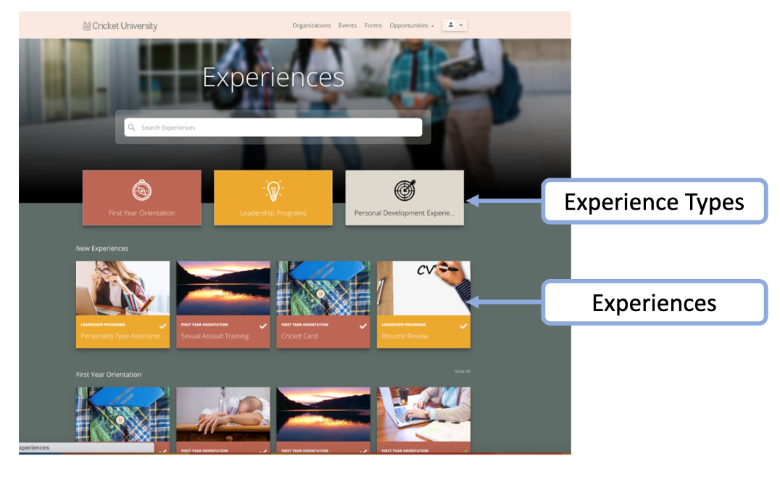

## Step 2: Plan the web page layout and content for your Experience Types.

*Make as many copies of the planning table as you need!*

When you’re building an Experience Page, you’re basically building out a web page. How do you want this to look when a student visits? **PLEASE SEE BELOW FOR EXAMPLES**.

**Potential Section Headers**

* I just want to design a flyer and then upload that; we only need one section!
* A section to explain what the experience or experience type is.
* What you will earn from this experience or experience type.
* A section with a flyer (provide alt-text).
* Logo
* Pictures or images (provide alt-text).
* Video – welcome video, instructions video, campus tour, etc.
* “Schedule”
* “Meet the Staff” w/ photos.
* “Goals for the Year”
* “Learning Outcomes”
* “Time Commitment”
* “Resources”
* “Qualifications”
* “
* “FAQs”
* …any other content you need!

|  |  |  |
| --- | --- | --- |
| Experience Type Title | | |
|  | | |
| Section Header | Section Content | If content contains images,  please provide altext. |
|  |  |  |
|  |  |  |
|  |  |  |
|  |  |  |
|  |  |  |
|  |  |  |

## Step 3: Plan the web page layout and content for your Experiences.

*Make as many copies of the planning table as you need!* ***See below for examples.***

|  |  |  |
| --- | --- | --- |
| Experience Title | | |
|  | | |
| Section Header | Section Content | If content contains images,  please provide altext. |
|  |  |  |
|  |  |  |
|  |  |  |
|  |  |  |
|  |  |  |
|  |  |  |

