
Points Worksheet
Your Institution:
Your branding guidelines:
Please provide the Hex color codes or a screenshot of your branding guide colors to use when making your tiles and headers.
Points are a great way to gamify and encourage participation in Campus Life. Think through your ideas with this worksheet so you are ready to create a robust and engaging Points Program in Presence!
- Intro to Points
- Creating Points
- Granting Points
- Redeeming Points
Part 1: Design Your Points Program
Points Program Name:
(This is your Points Type)
What is your goal for this points program?
Which departments are involved?
Who can earn points?
How can students earn these points?
Point Value | ______ Points | ______ Points | ______ Points | ______ Points | ______ Points
Prize(s)
How will students redeem their points?
Do points expire? When?

Part 2: Design Your Points Page
When you’re building a Points Page, you’re basically building out a web page. How do you want this to look when a student visits? PLEASE SEE BELOW FOR EXAMPLES.
Potential Section Headers
- “User Guide”
- “Featured Event”
- “Prizes”
  - List of prizes
  - Images of prizes
  - Video of prizes
- “FAQs”
  - “How to Redeem Points”
  - “How to Earn”
  - “How long do points last?”
  - “Where do I pick up prizes?”
  - “Who is eligible for points?”
- … any other section you need!
Points Program Name
Section Header  (Do you want any subsections?) | Section Content | If content contains images,  please provide altext.

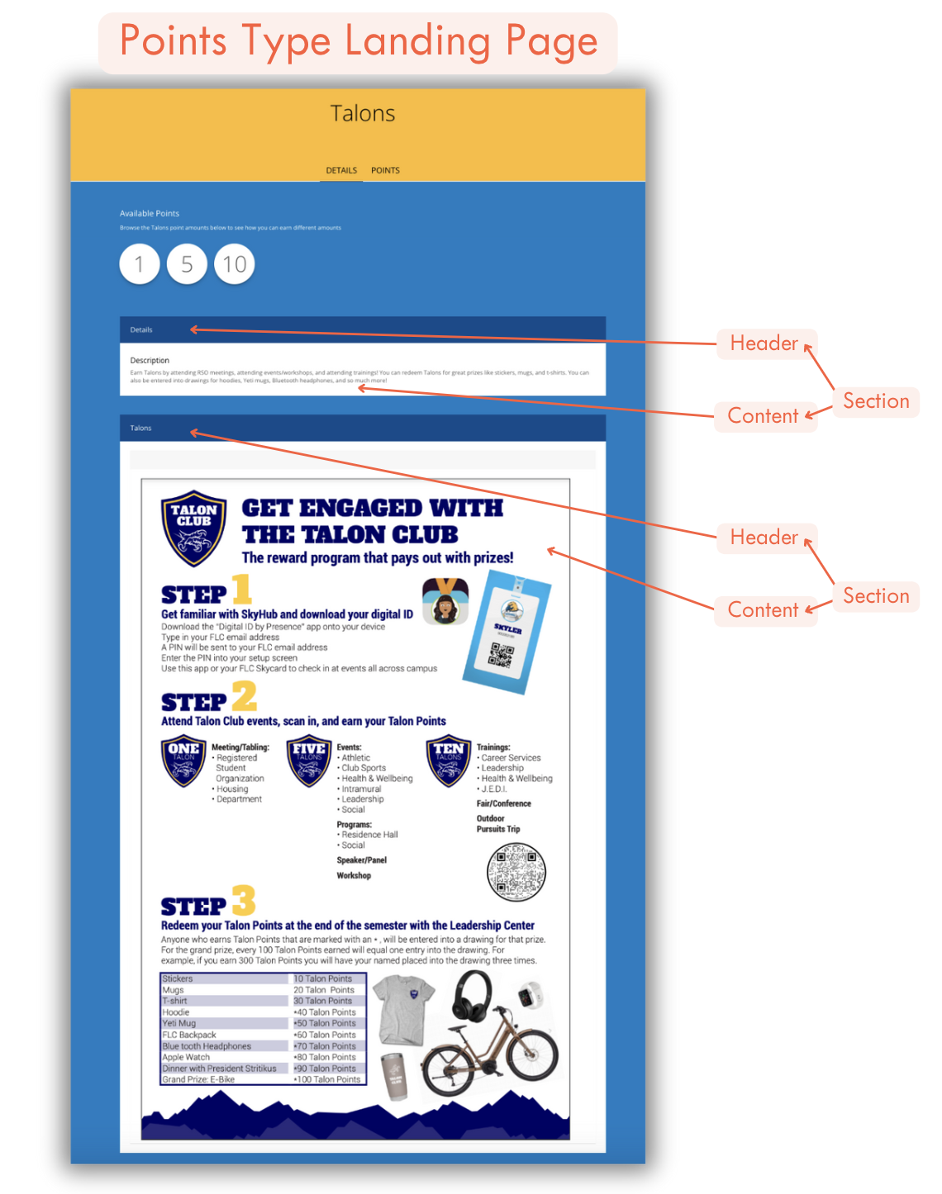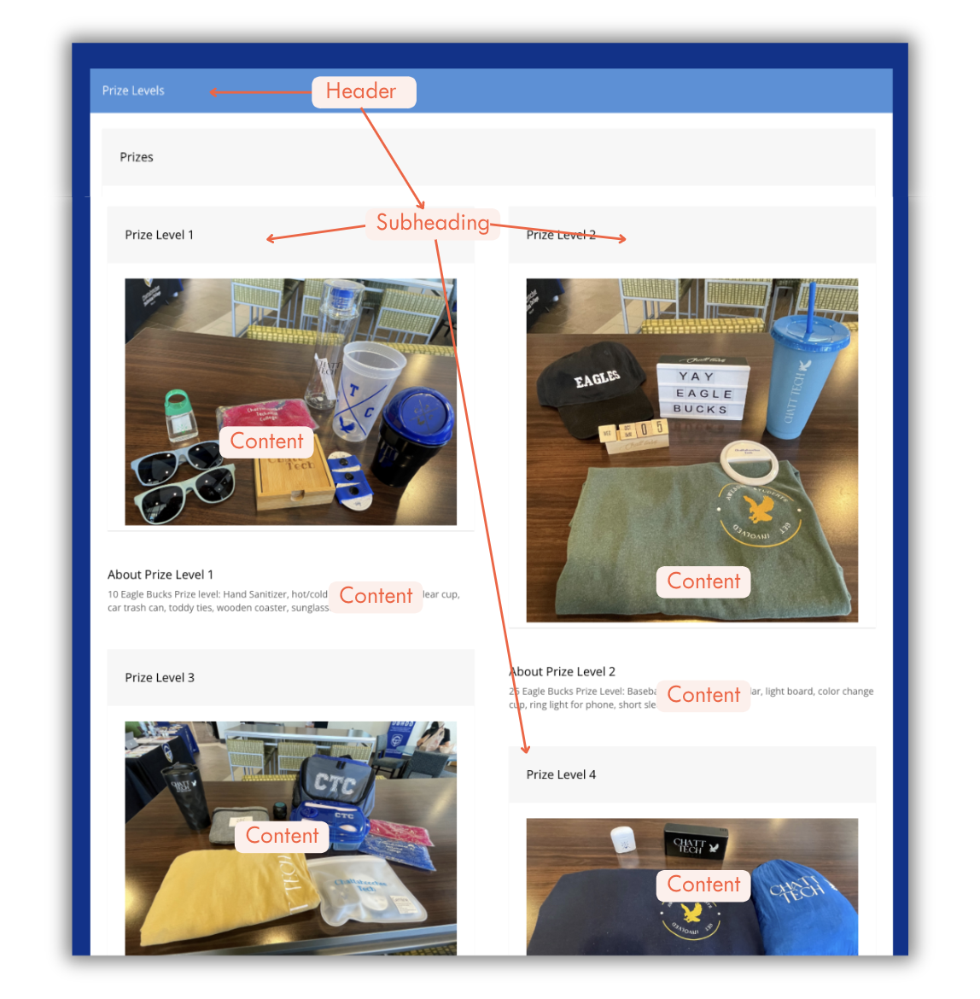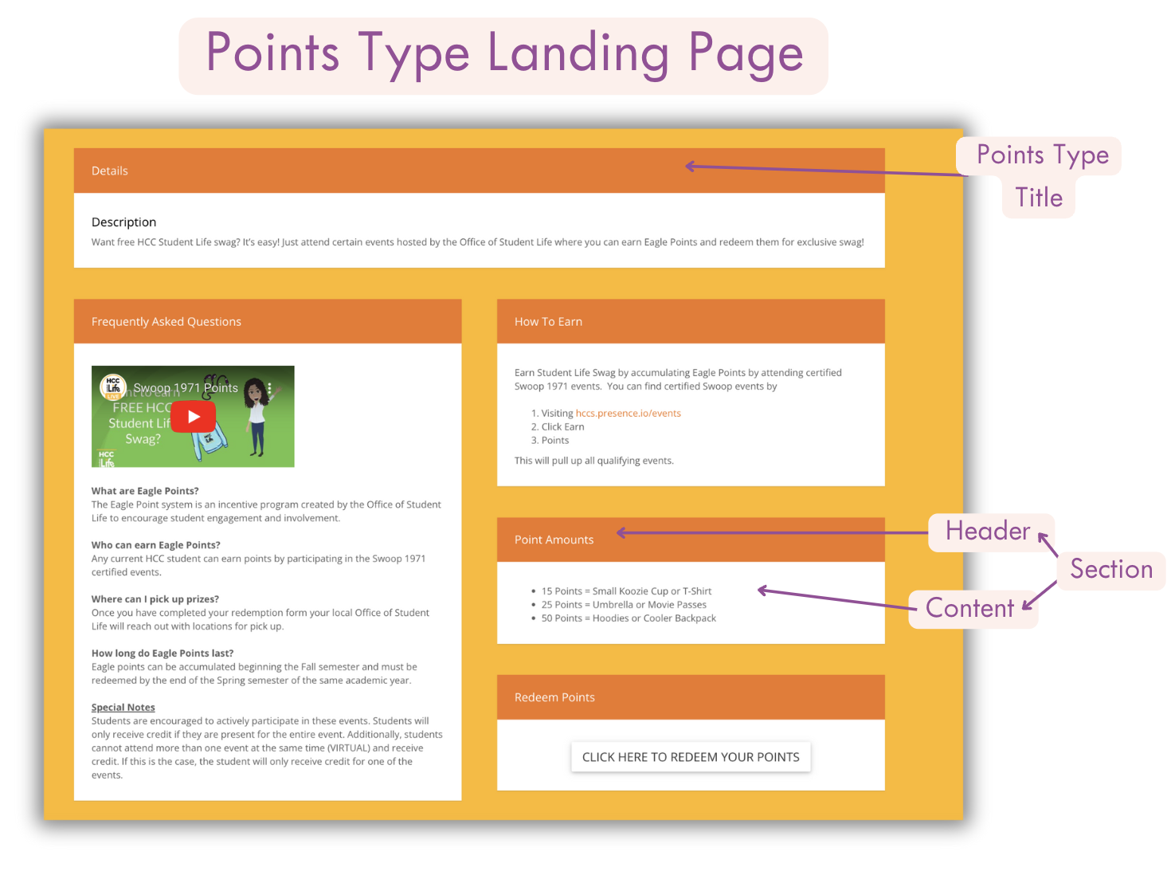
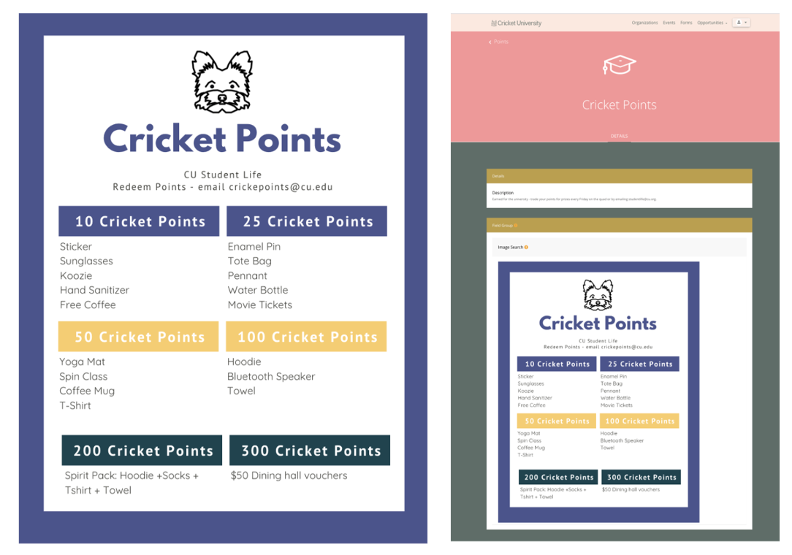
Use the “Cricket Points” template on Canva!
https://www.canva.com/design/DAFktAVJnhE/fHGJC4Bz9SpauPocUtxglg/view?utm_content=DAFktAVJnhE&utm_campaign=designshare&utm_medium=link&utm_source=publishsharelink&mode=preview

